Drummond Island Residents,
Our community is at a pivotal moment. As we look to the future, it’s essential to identify the guiding principle—or “north star”—that will shape our township’s strategic direction. This shared vision will help us prioritize initiatives, allocate resources, and ensure that our decisions reflect the values and aspirations of everyone who calls Drummond Island home.
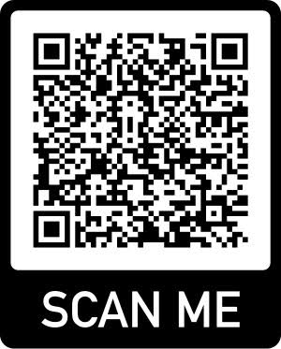
To begin this process, we’re launching a community questionnaire, running from May 1 to May 31. This is your opportunity to share your thoughts, concerns, and hopes for the future of our island. Your input will be invaluable in defining what matters most to our community and setting the course for the years ahead.
The questionnaire will cover key topics affecting Drummond Island’s future, including:
Community Priorities: What local issues concern you most? How important are affordable housing, emergency services, recreational development, and support for seniors and young families?
Public Safety: Do you feel safe on the island? What improvements to emergency response and law enforcement presence would be most beneficial?
Tourism: How can we balance the economic value tourism brings to our community with its associated costs, such as increased traffic, environmental impact, and strain on local resources?
Infrastructure & Development: What capital improvements should the Township prioritize? Should we invest in road maintenance, recreational facilities, or public water access?
Township Facilities: Which community spaces do you and your family value most? Parks, beaches, the golf course, and more.
Long-Term Vision: How do you see our community growing in the next decade? What aspects of Drummond Island’s identity should be preserved? What new opportunities should be explored?
This questionnaire is not just a tool; it’s the first step in a collaborative journey. By participating, you’re helping lay the foundation for a stronger, more connected Drummond Island. The survey can be accessed online via our website drummondislandtownship.org, by scanning the provided QR code, or by picking up a physical copy at the Township Hall.
Your voice is vital—let’s make it count and move forward together.

Warm Regards,

Krystal Truax

